1. **Create relational schema based on your E-R diagram**

[**Phase 2 Relation Schema**](https://www.lucidchart.com/invitations/accept/2c2af6d5-ca35-4afb-acac-1f932c2ba6db)

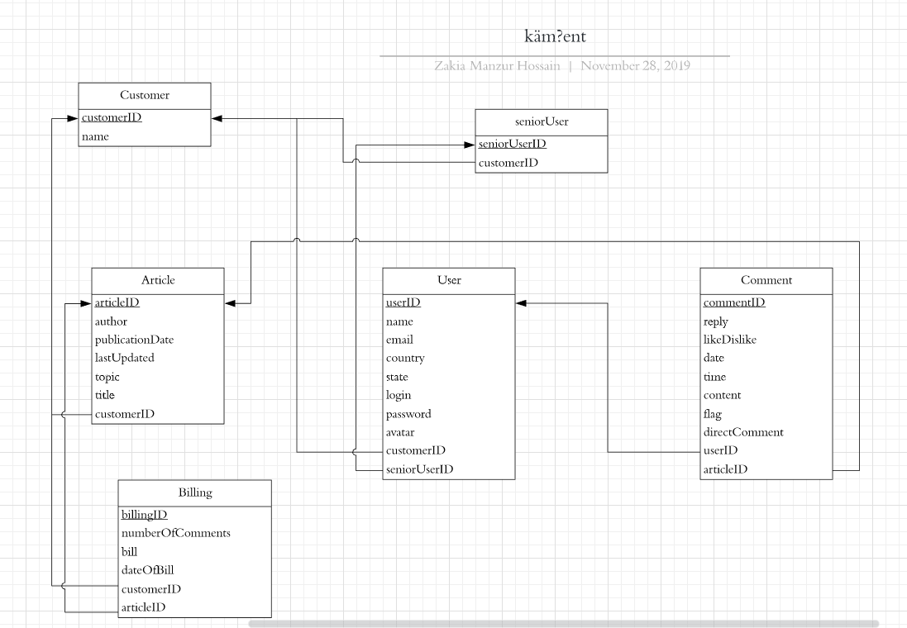

1. **Create relations in your database**

Customer:

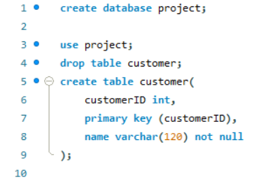

Article:

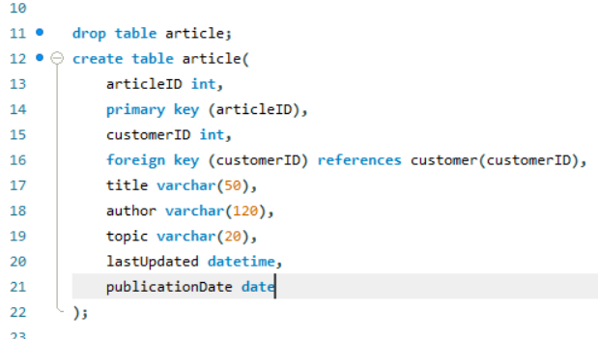

Billing:

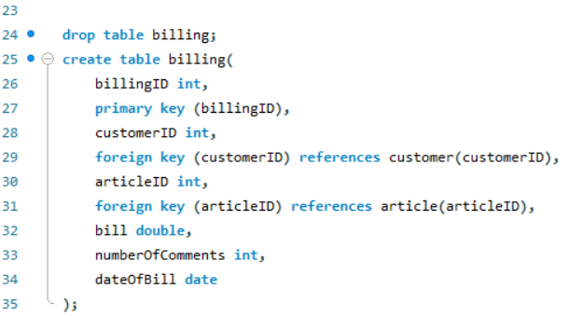

seniorUser:

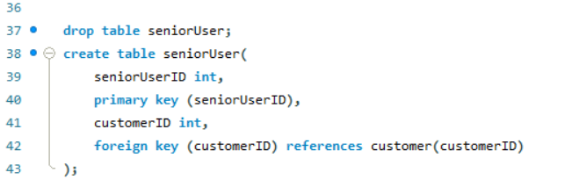

User:

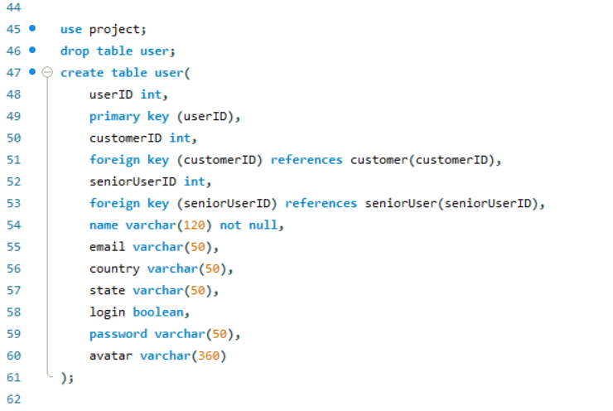

Comment:

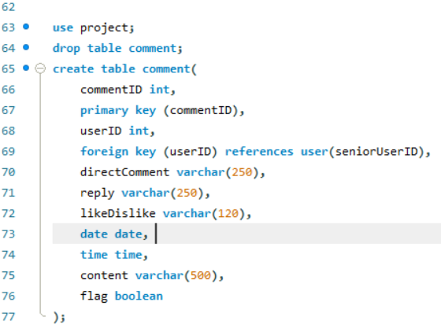

1. **Describe the challenges you met while implementing this phase of the project**

After I turned my E-R diagram into a relation schema I do not see any significant differences or changes. When creating the tables in the database, I figured that I don’ t really know how to define a primary key or a foreign key. I also don’t know what constraints to implement and what to do it we are referencing a data from an existing table in another table. I would have to study up on that.

**Updates**

I looked at my assignment 2 to figure out the foreign key and primary key SQL syntax and modified my diagrams and SQL statements.